**LAB # 06**

**UNSUPERVISED LEARNING (K-MEANS CLUSTERING**

**ALGORITHM) AND UNSUPERVISED LEARNING (APRIORI ALGORITHM)**

**OBJECTIVE:**

Implementing unsupervised learning, K-means clustering algorithm for training, testing and classification and implementing Apriori Algorithm for training, testing and classification.

**LAB TASKS:**

1. A dataset (income.csv) has been provided. Implement K-Means Clustering Algorithm on this dataset using K (number of clusters = 3). Also find out new centroid values based on the mean values of the coordinates of all the data instances from the corresponding cluster



***SOURCE CODE:***



***O***



***UTPUT:***

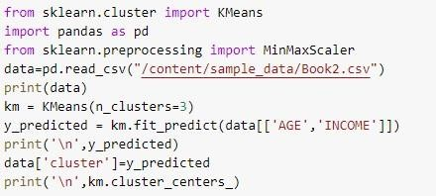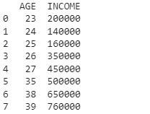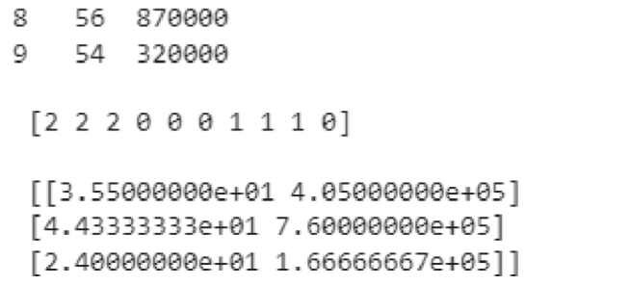

1. The following sample dataset contains 8 objects with their X, Y and Z coordinates. Your task is to cluster these objects into two clusters using K-Means Clustering Algorithm (here you define the value of K (of K-Means) in essence to be 2).

***OUTPUT***

**:**



***S***



***OURCE CODE:***

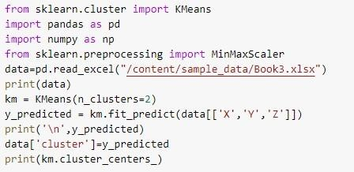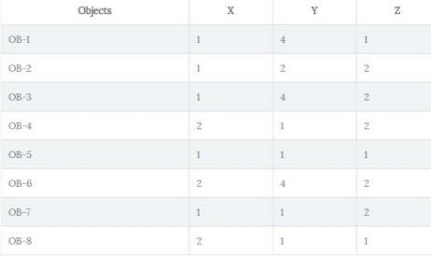

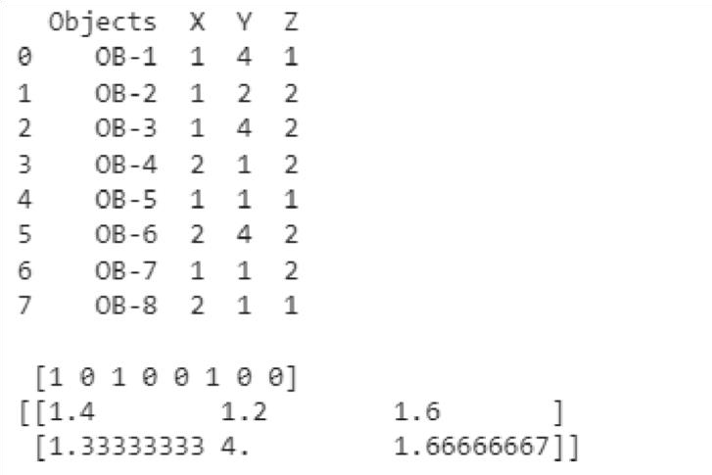

1. Run the given code of Apriori Algorithm and show the output.

***O***

***utput***

***:***



***SOURCE CODE:***

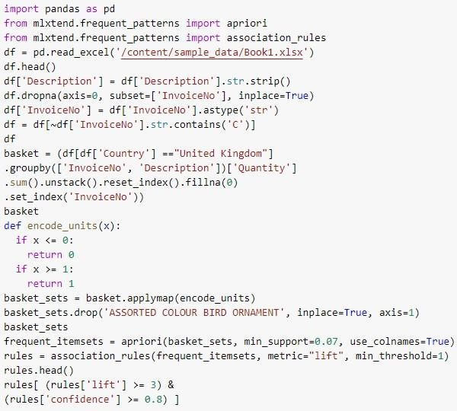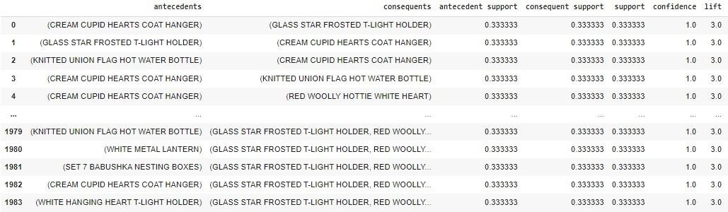

1. In given code there is a support value of at least 7%, Generate frequent item sets that have a support value of at least 5%

***O***

***utput***

***:***



***S***



***OURCE CODE:***

